**USER**

**MANUAL**

INSPECT

**CONTENTS PAGE**

1. OVERVIEW 2

2. SECTION ONE: GETTING STARTED 4

2.1 Downloading App.

2.2 App Permissions.

3. SECTION TWO: MAIN MENU 6

3.1 Start Inspection

3.2 Edit Template

3.3 Share File

3.4 Create New Template

3.5 Back

4. SECTION THREE: CREATING A TEMPLATE 8

5. SECTION FOUR: EDITING A TEMPLATE 16

6. SECTION FIVE: STARTING AN INSPECTION 18

7. SECTION SIX: SHARING THE INSPECTION FORM 23

8. SECTION SEVEN: TROUBLESHOOTING 25

9. SECTION EIGHT: USER FEEDBACK 26

**OVERVIEW**

**Inspect** is an application used to streamline the inspection process for businesses, providing a software solution will solve is the duplication of paperwork created by on-site inspections. Often traditional paper forms are taken on-site and filled out, then at a later date and time, digitised and photos added. This App provides a solution that will bridge the gap between initial on-site inspection and the digitisation process that occurs later and in the process saving resources, time, and money.

BACK TO CONTENTS PAGE

**SECTION ONE: GETTING STARTED**

**2.1 DOWNLOADING THE APP:**

**1.** Download the Inspect App from Android’s Google Play Store

(Download link: [https://play.google.com/apps/testing/com.binarygiant.inspect)](https://play.google.com/apps/testing/com.binarygiant.inspect)

**2.** Tap the Inspect App Icon to access the App.



**2.2 APP PERMISSIONS:**

1. Before using the App, ensure that permissions are allowed to access photos, media and files on the device as well as take pictures and record video.

This will prove to be useful in the event of adding photos to the inspection form/template that are taken directly by the camera. Saved files/templates can also be located in the event of editing an existing template or sharing it with a client.

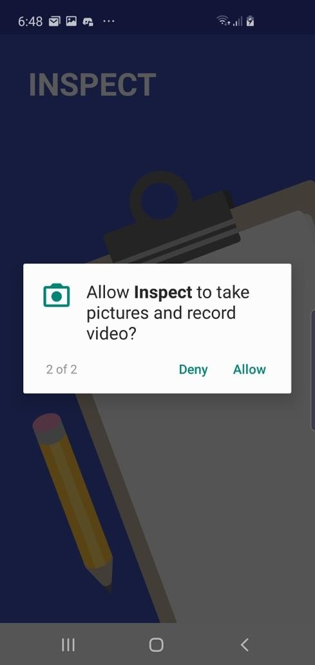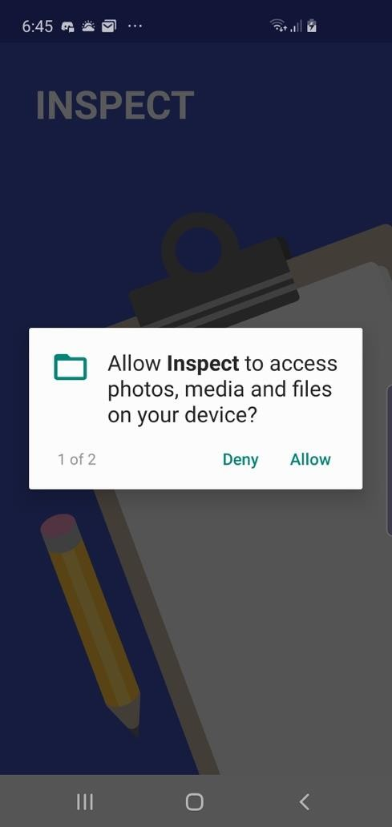

**2.** Once the Inspect App has been granted these permissions, tap to begin using the App.

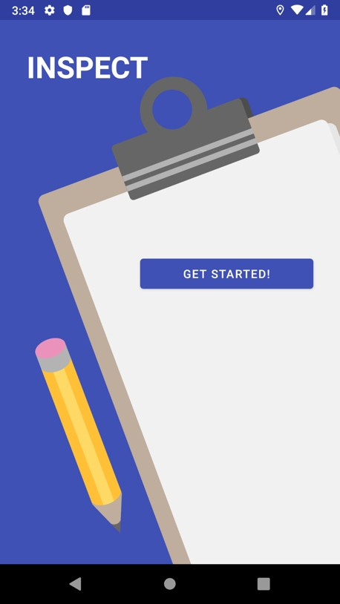

BACK TO CONTENTS PAGE

**SECTION TWO: MAIN MENU**

**OVERVIEW OF MAIN MENU FEATURES**

Located on the main menu are the following features:

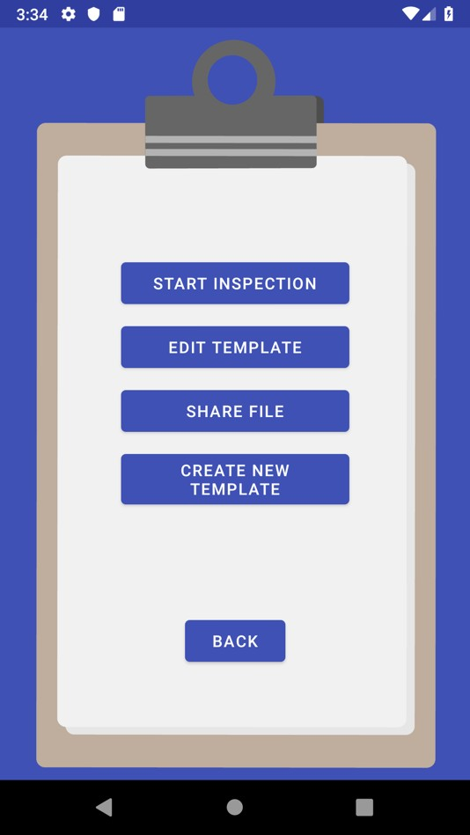

**2.1 - START INSPECTION:**

Tapping the button will allow the user to select an existing template that has been created and saved and fill it out during an on-site inspection. These additions to the inspection form can be saved and returned to later, previewed, or shared/sent to the client.



**2.2 - EDIT TEMPLATE:**

Tapping the button will allow the user to select an existing template that has been created and saved and make changes to it as per the needs of the inspection. These changes can be saved and returned to later.



**2.3 - SHARE FILE:**

Tapping the button will allow the user to select an existing template that has been created and saved, preview it in the form of a PDF file and share and/or send it to the client accordingly.



**2.4 - CREATE NEW TEMPLATE:**

Tapping the button will allow the user to create their own inspection form with their own customizable headings, questions, placeholders for photos to be attached as well as number of desired pages.



This template can be saved and returned to later – either in the process of editing it further through the EDIT TEMPLATE feature or filling it out during the inspection phase through the START INSPECTION feature.

**2.5 - BACK:**

The button will take you back to the previous introductory screen to ‘GET STARTED!’



BACK TO CONTENTS PAGE

**SECTION THREE: CREATING A TEMPLATE**



**1.** To commence the process of creating a template, tap the button on the main menu screen.





**2.** A textbox will appear below the button, prompting you to enter the desired name for this template. Once you have named the template, tap the button to the right of the textbox.

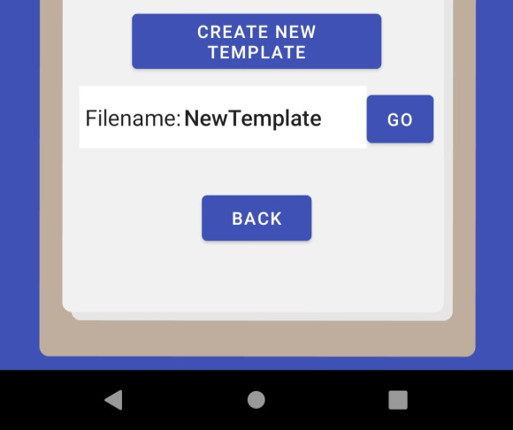

**3.** A blank template will appear containing a column of pencil icons.

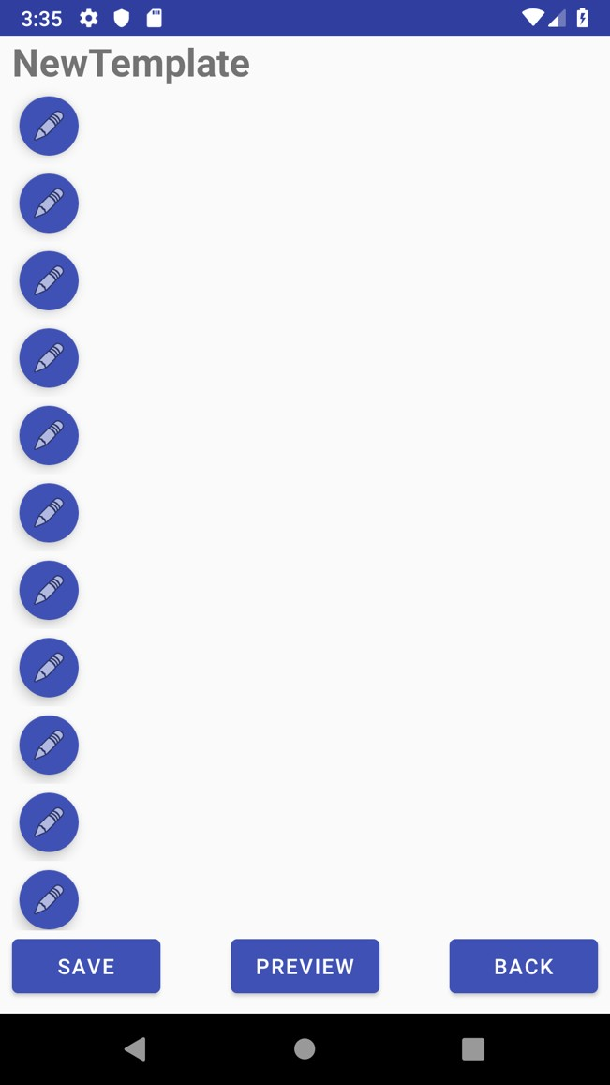

Tapping the icon will allow a horizontal slide menu of buttons to appear across the top of the screen. These can be scrolled through to add custom elements to the template you will be creating.



- To add a Heading to the template, tap the button and enter a heading in

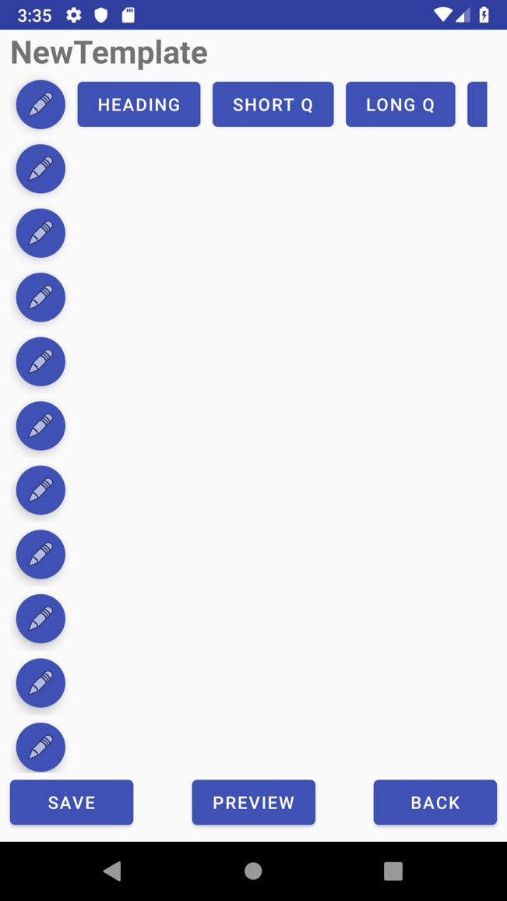

the textbox that will appear beside it.

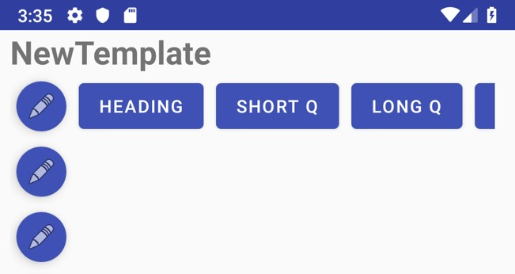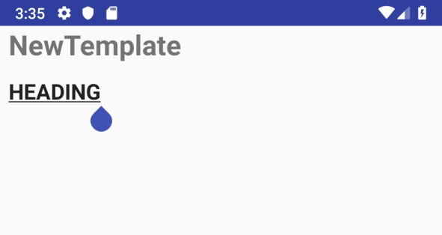

Once you have entered the desired Heading element for your template, simply scroll back to the left of the screen to view the pencil icons to add other elements to your template.

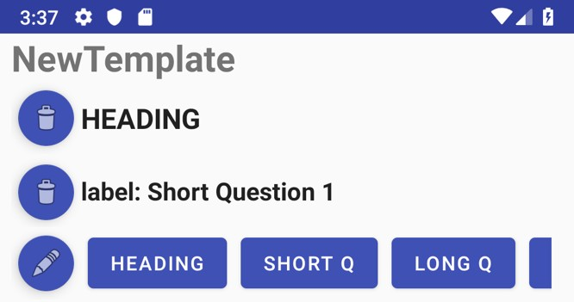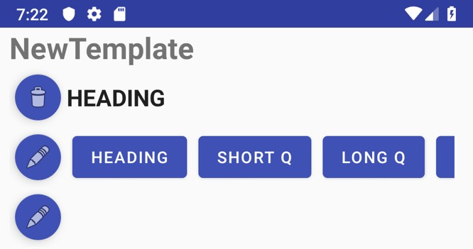



- To add a Short Question to the template, tap the button and enter a short question in the textbox that will appear beside it.

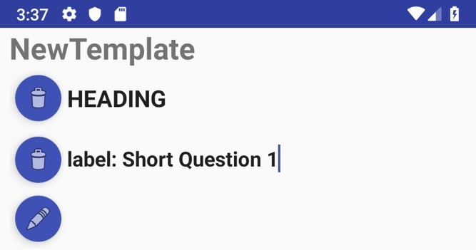

- To add a Long Question to the template, tap the button and enter a

long question in the textbox that will appear beside it.

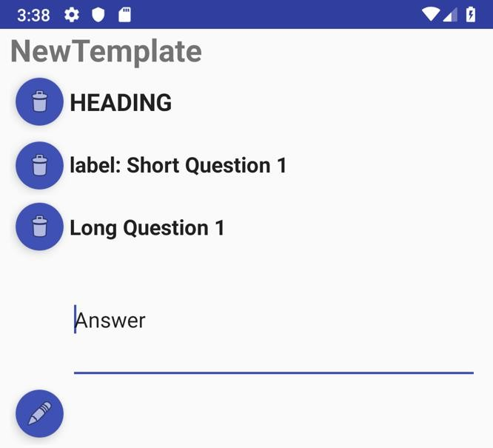



- To add a placeholder for a photo to be attached to the template, tap the button. A photo logo/icon will appear – this will function as a placeholder during the Inspection process for photos to be added in its place. NOTE: You will have to scroll through the horizontal elements menu to access the A blue and white sign
button.

**1.**

**2.**

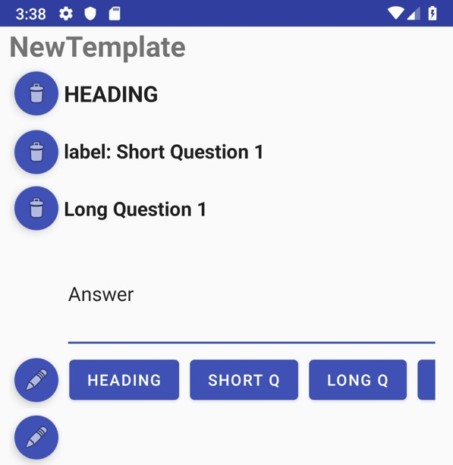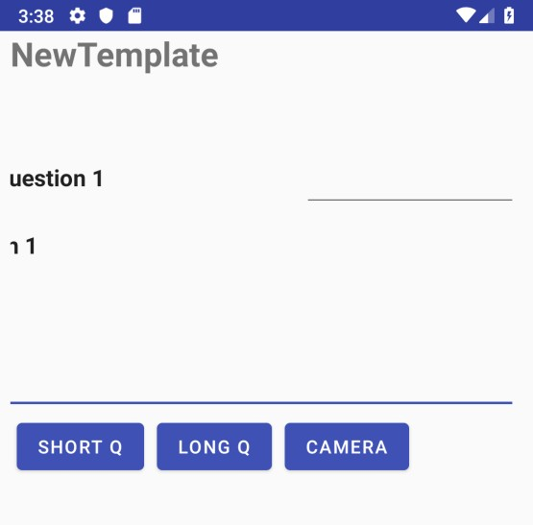

**4.**

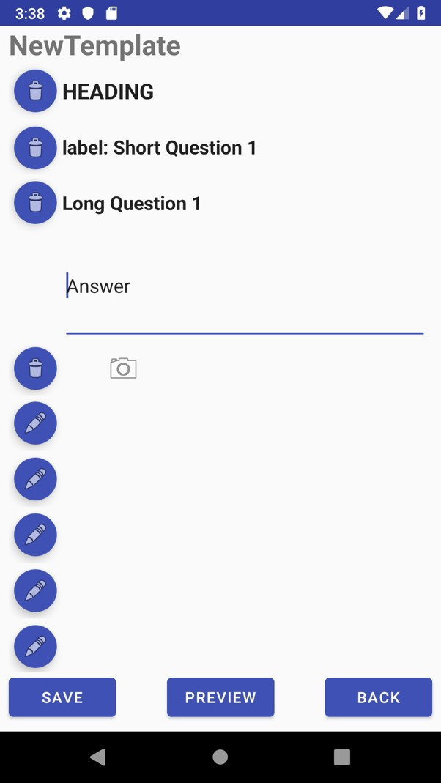

**3.**

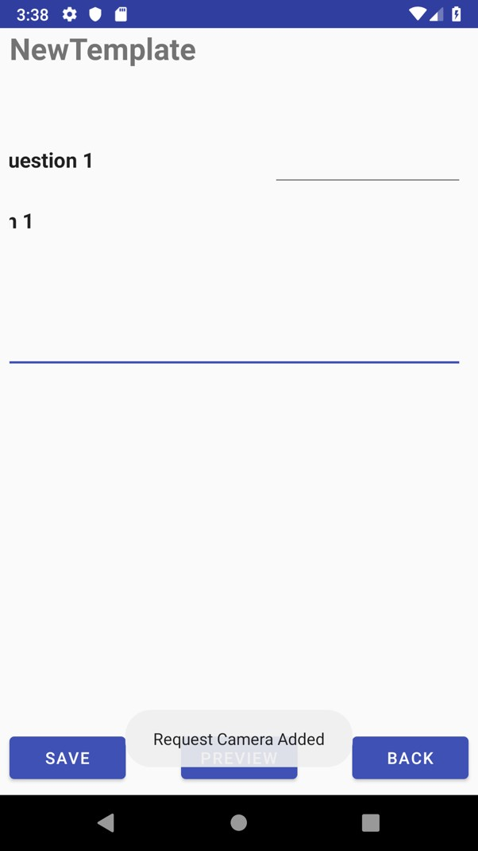

- To go back and edit previous fields or elements, simply tap on the textboxes for each element added to make the necessary changes.

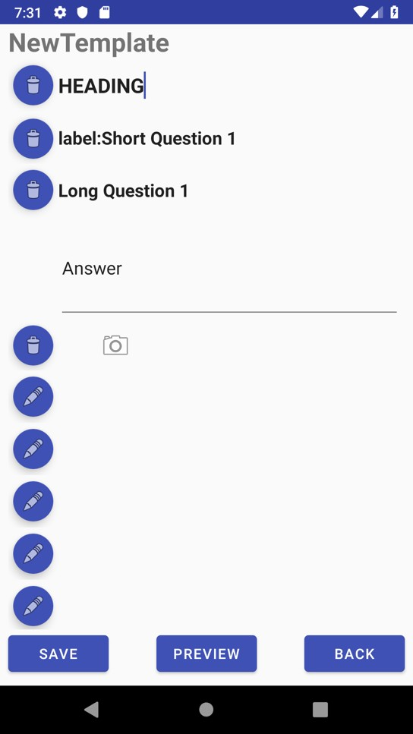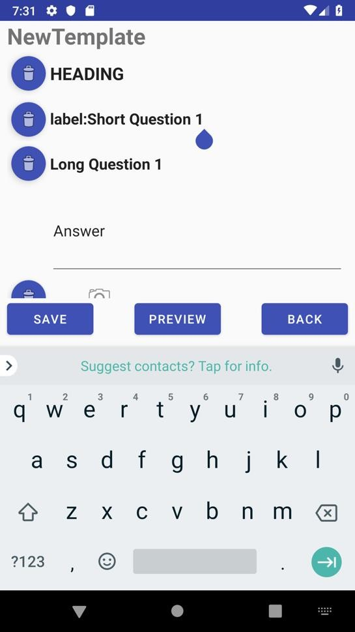

NOTE: To remove any elements you have added, simply tap on the icon next to the element you wish to delete. The icon will appear once you have added an element.



* To add a page to your template, scroll down to the bottom of the screen and tap on the icon. A new page will then be added with its own column of icons to add/remove elements.

**2.**

**1.**

**4.**

**3.**



- To preview your current template, tap the button at the bottom of the

screen. Once you have seen your template previewed, tap on the button to



return to your template.

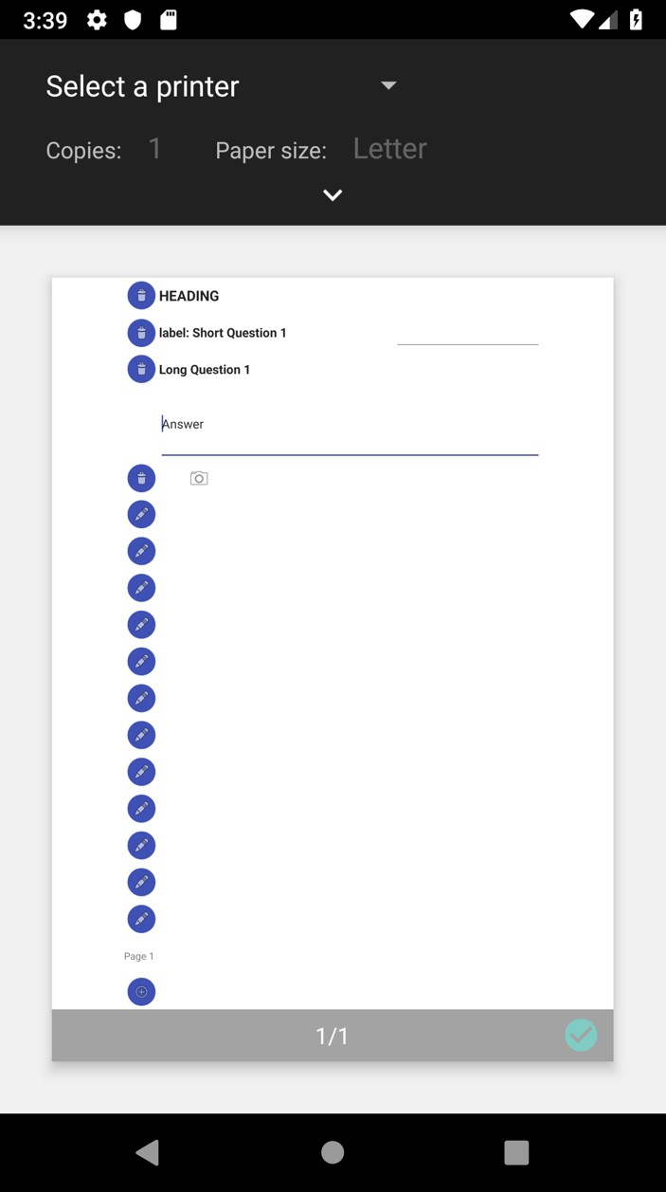

**4.** Once you have created your template and added the desired elements, tap the button at the bottom of the screen to save your template. A brief prompt confirming your template has been saved will then appear.

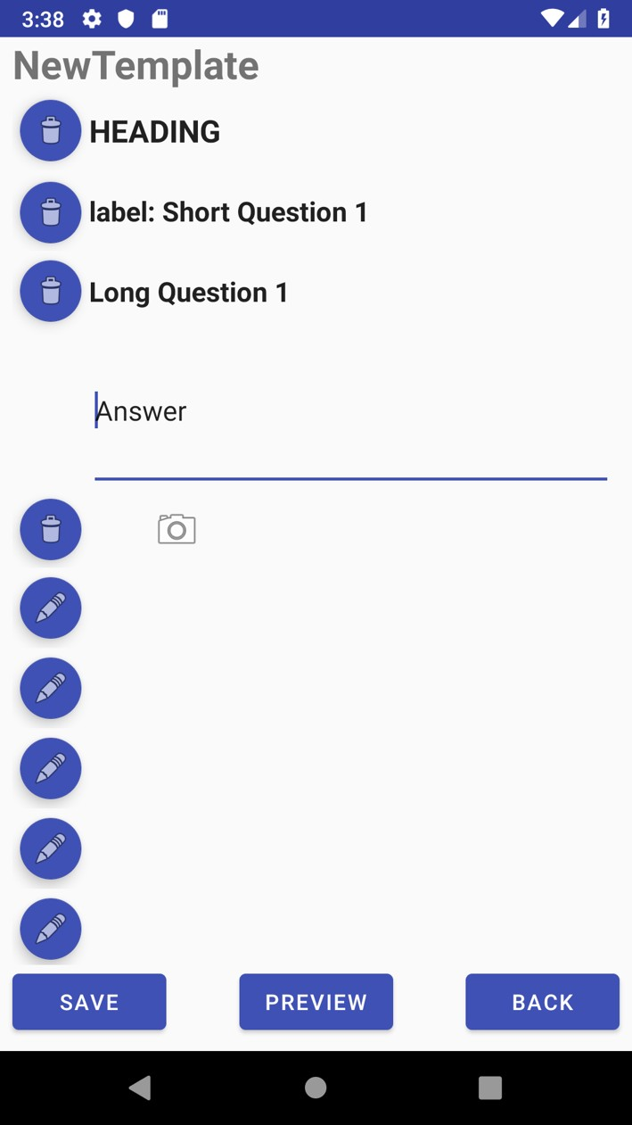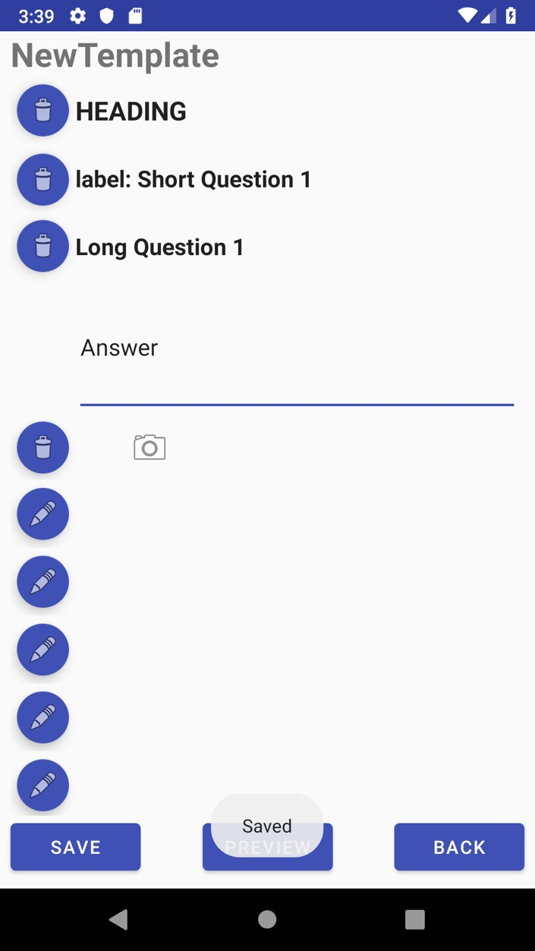

**5.** To return to the main menu, tap on the button at the bottom of the screen.



BACK TO CONTENTS PAGE

**SECTION FOUR: EDITING A TEMPLATE**

**1.** To commence the process of editing an existing template that has already been created

and saved, tap the button on the main menu screen.



**2.** A prompt will appear in front of the main menu, asking you to choose the file you wish to edit. Select the template you have already created and saved.

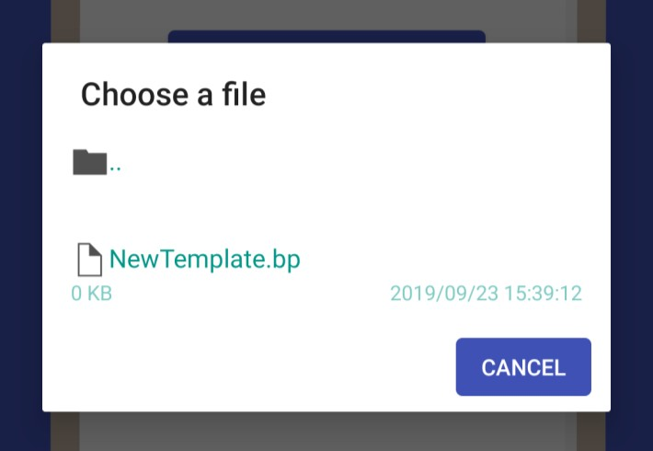

**3.** Your saved template will now appear in edit-mode, allowing you to make the desired changes to it.

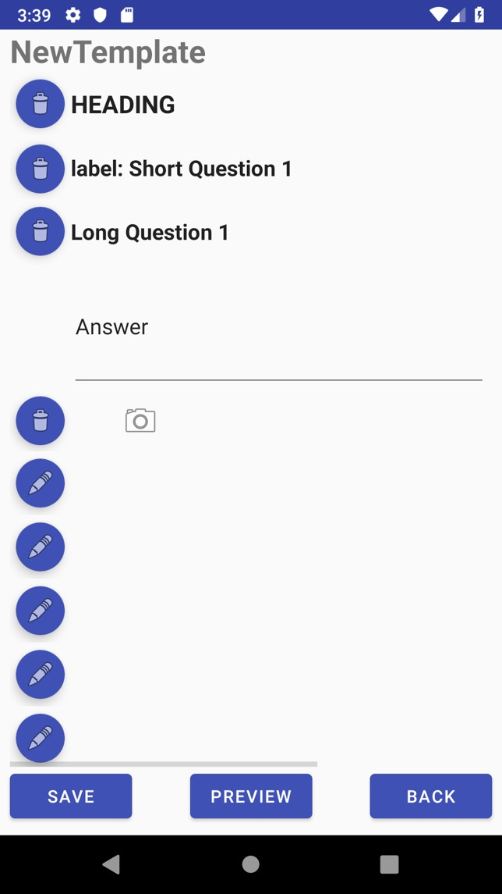



**4.** Once you made the desired changes/edits to the template, you may select the

button at the bottom of the screen to preview your template with these currents changes or tap the button to save these changes.

5. To return to the main menu, tap on the button at the bottom of the screen.



BACK TO CONTENTS PAGE

**SECTION FIVE: STARTING AN INSPECTION**



**1.** To commence the process of starting an inspection – that is, filling out a custom made template that has already been created and saved – tap on the button on the main menu screen.

**2.** A prompt will appear above the main menu, asking you to choose the file or template you wish to use for the inspection. Select the desired template for the inspection.



**3.** Your saved template for inspection will now appear in inspection-mode, allowing you to fill out the template and carry out in the inspection process.

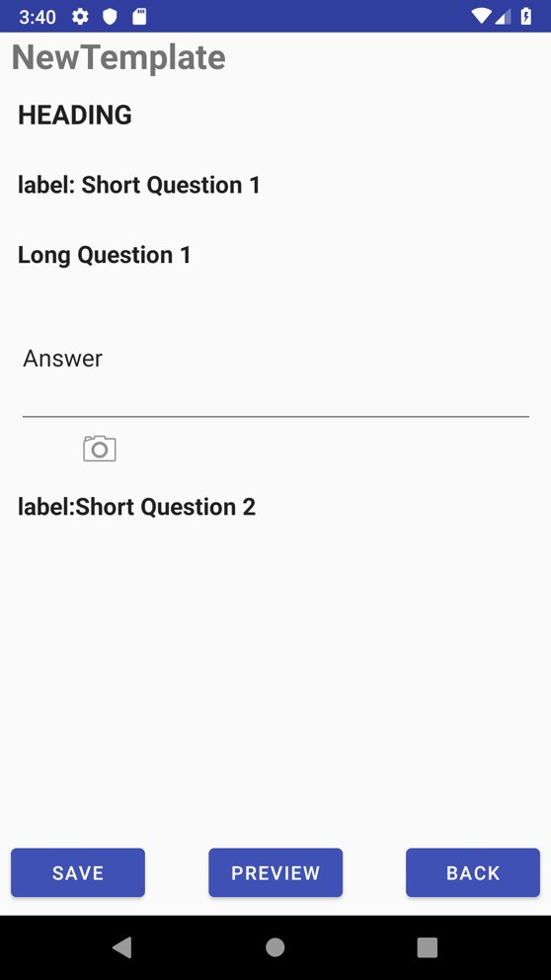

**4.** During the on-site inspection, simply tap on the textbox fields already added to the custom template and fill them out with the necessary details.

To add a photo to the template, simply tap on the icon that you added either during the CREATING A TEMPLATE or EDITING A TEMPLATE stages.

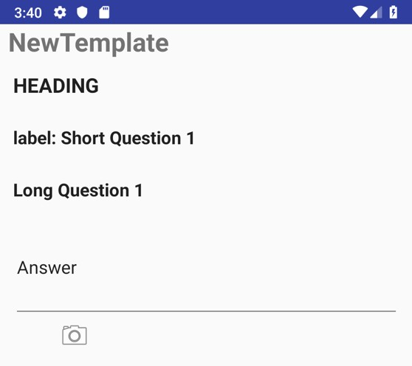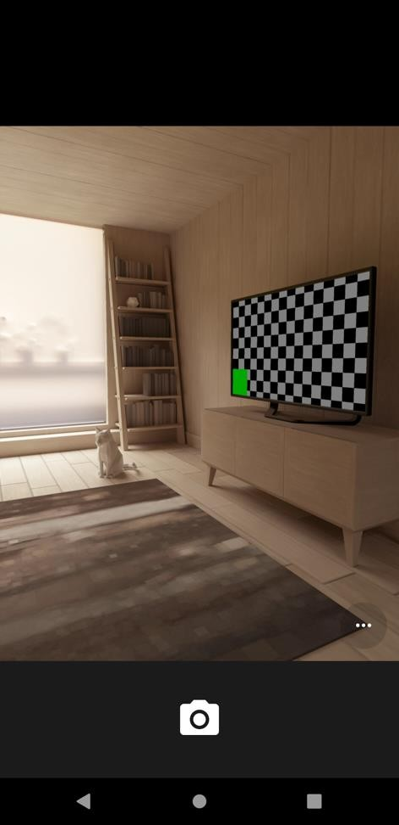

**5.** You will then be taken to the camera on the device. Tap on the icon to take a photo and then tap on the icon to approve the photo and add it to the template.

The photo will now appear in place of the camera logo placeholder in the template.

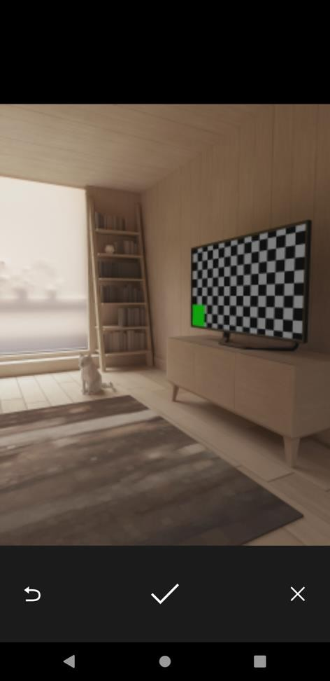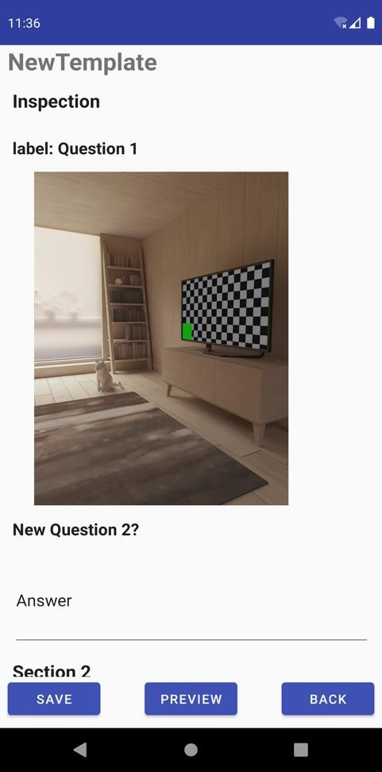



**6.** Once the template has been filled out to the user’s satisfaction, tap on the button at the bottom of the screen to save these changes. These changes can be returned to later via the STARTING AN INSPECTION phase to complete the inspection process at a later time or the EDITING A TEMPLATE phase to go back and edit certain fields/elements which may/may not be required for the inspection.

**7.** To preview the template in its current (completed or partially completed) form, tap on

the button at the bottom of the screen.

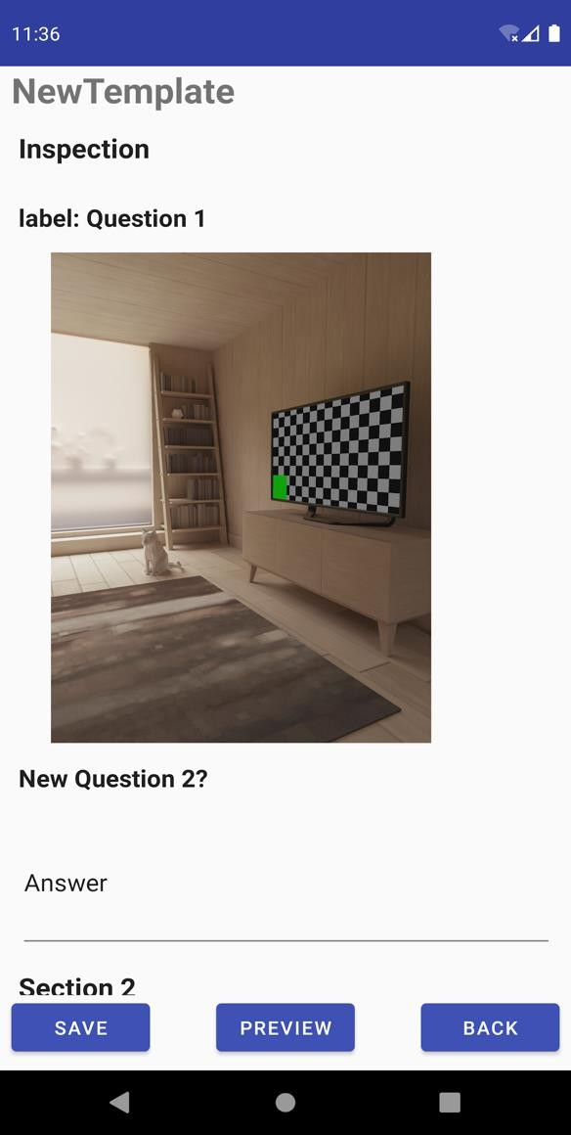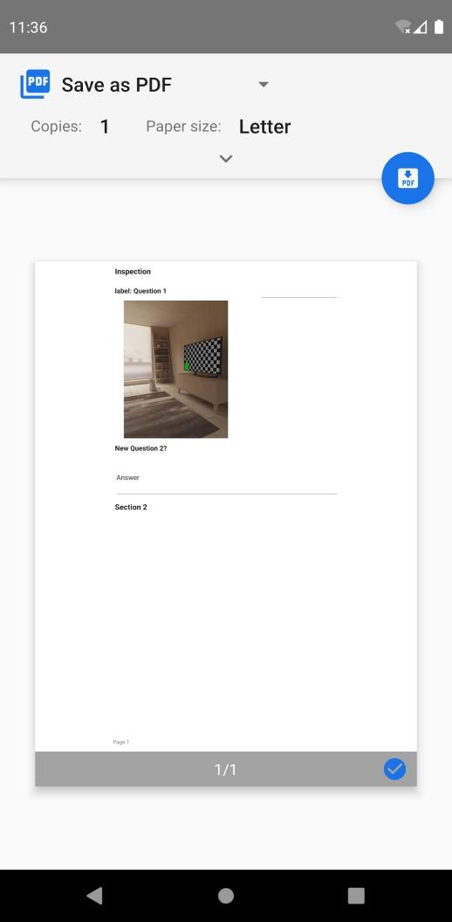

**8.** To save the completed inspection form as a PDF file, tap on the

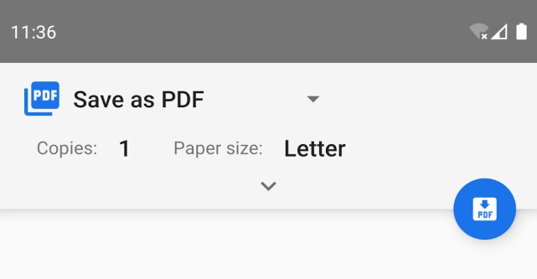

button at the top of the preview screen.

**9.** Tap the button to save the output PDF file.

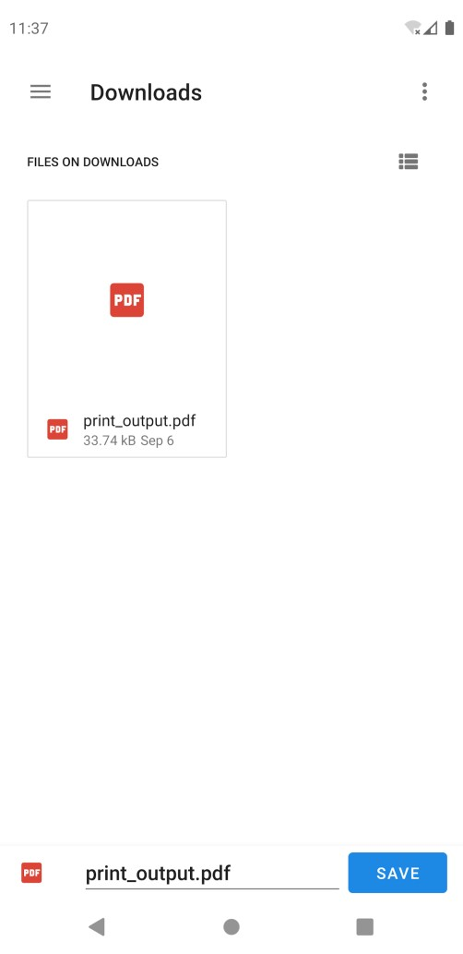

**10.** To return to the main menu, tap on the button at the bottom of the screen.



BACK TO CONTENTS PAGE

**SECTION SIX: SHARING AN INSPECTION FORM**

**1.** To commence the process of sharing the completed inspection form with the client, tap on the button on the main menu screen.



**2.** A prompt will appear above the main menu, asking you to choose the file you wish to share (or send to) the client. Select the desired file for sharing.

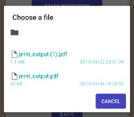

**3.** Select the email client with which you would like to communicate with the client (Hotmail, Gmail, etc.). Simply enter the client’s email address (the file itself will already be attached to the email) and tap the send icon.

BACK TO CONTENTS PAGE

**SECTION SEVEN: TROUBLESHOOTING**

**EXAMPLE: When coming to preview an inspection form – either when creating a template, editing a template, starting an inspection, or sharing the file – it may not always allow you to preview the document as a PDF file (as seen in the screenshot below).**

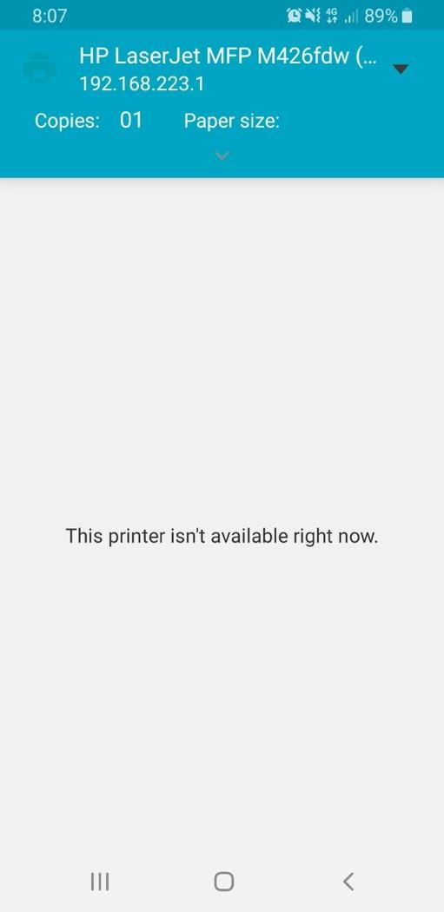

BACK TO CONTENTS PAGE

**SECTION EIGHT: USER FEEDBACK**

1. To access the user feedback form to provide feedback on the Inspect App, please click on the following link: <https://forms.gle/E4iw6JjeybwvxNoZ7>

During this survey, you will be asked to complete four tasks then answer questions base on those tasks. The tasks include:  
• Making a Template  
• Editing a Template  
• Completing an Inspection  
• Sharing a file  
  
After this, you will be asked your opinion on the application and the possible ways in which we can improve it. You may be asked to complete this survey again at a later date to compare changes made.  
  
NOTE: You may need to use both your computer and phone to complete this survey



1. To begin filling out the Inspect Feedback form, click on and follow the prompts to complete the survey.

1. Once you have completed filling out the Inspect Feedback form, click on to submit your responses.

BACK TO CONTENTS PAGE